CS 2302 Data Structures

Fall 2019

Lab Report #7

Due: December 4, 2019

Professor: Olac Fuentes

TA: Anindita Nath

**Introduction**

In this lab the task was to implement a hamiltonian check as well as a modification for a edit distance segment of code given to us in class.

**Proposed Solution Design and Implementation**

The start is an easy one since we were given sudo code for finding a hamiltonian cycle so i will just need to conver it from sudo code to real code. And then for the modified edit distance i just need to add a few checks to the given code to comply with the lab.

**Experimental Results**

**Part 1:**

This was very simple to implement. We were tasked with determining if a given graph had a hamiltonian cycle in it. Since we were given the pseudo code It was just a simple conversion from pseudo code to actual code. Here is my trial result:



**Part 2:**

This was also super simple. We needed to modify a a given code segment to meet the constraints given to us. Here are those results:



**Overall Lab Results:**

Overall their was not much variance in the results due to having a very specific question to solve.

**Conclusion**

After finishing the lab i think i have a solid grasp on certain concepts behind graphs and other similar topics.

**Appendix**

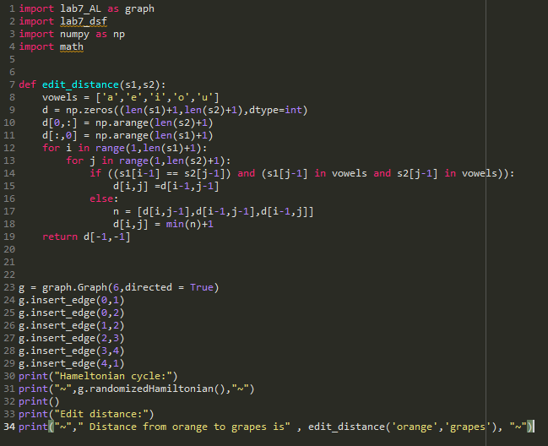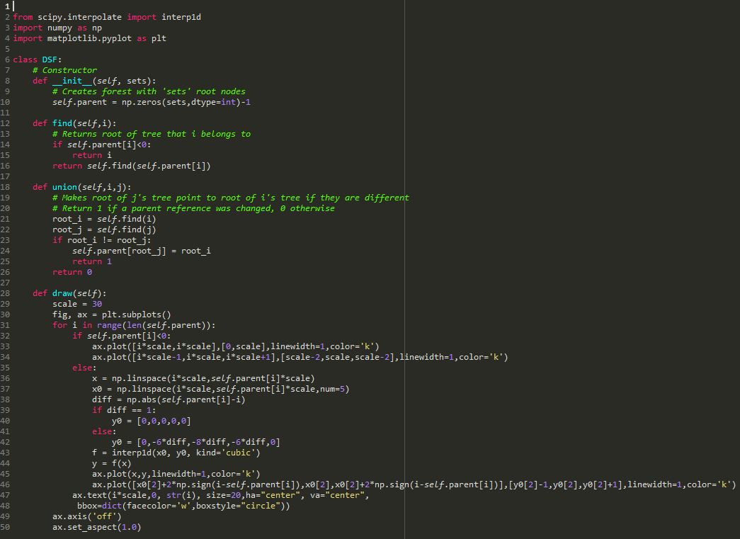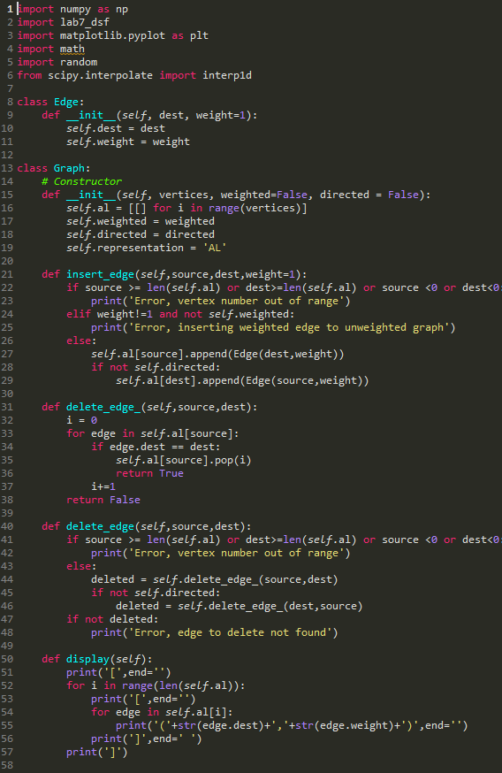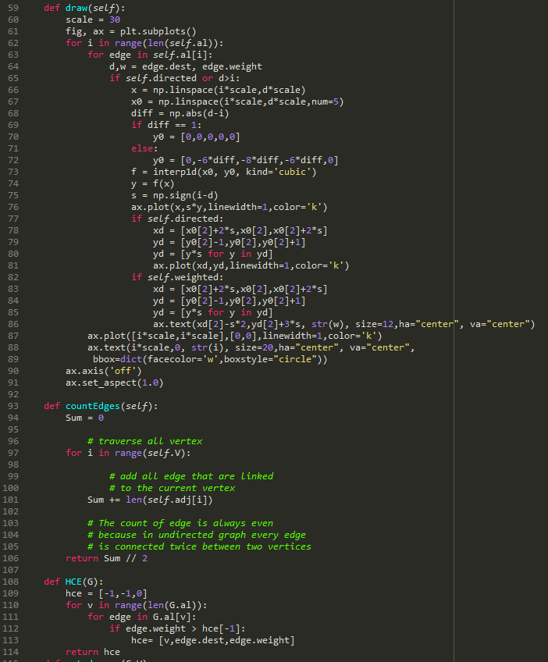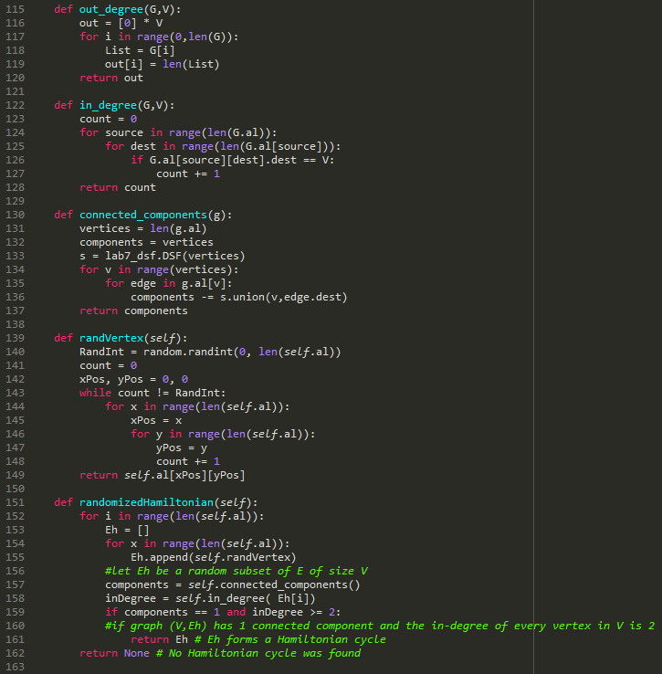

*I certify that this project is entirely my own work. I wrote, debugged, and tested the code being presented, performed the experiments, and wrote the report. I also certify that I did not share my code or report or provided inappropriate assistance to any student in the class*

Justus Frausto